Merging an SAP PS project with MS Project
Introduction
This article reviews a subroutine for building the Microsoft Project hierarchy from an SAP PS project.
SAP PS is a part of the SAP ERP system used by most of the fortune 500 companies. The SAP PS module is highly integrated with other SAP modules including FI, Controlling, MM, HR, Capacity Planning, Plant Maintenance, etc. SAP PS is a highly detailed project control tool. MS Project is the tool of choice for working a project, with a team, at a task level (rough project planning).
Merging these two systems usually entails using, very expensive, third party software such as Impress or Pipelinesoftware through a custom development process. A standard alternative is to use the free, SAP provided, OpenPS interface as the integration mechanism. Problematically, the OpenPS interface is non-configurable.
The code provided will integrate an SAP PS project into MS Project, in both directions, to a task level. You can create a new MS Project from SAP PS, insert new tasks in MS Project that are uploaded to SAP PS, create new tasks in MS Project that are not uploaded to SAP PS, or create new WBSs and Network-Activities in SAP PS that are transferred to the target MSP project.
Creating the MS Project Hierarchy from SAP PS data
First step is to get the project data from SAP. This C# code uses the SAP Net Connector 2.0 with .Net 3.5 to make a call to SAPs “BAPI_PROJECT_GETINFO” function. It returns all the data we need. The CodeProject website already has an excellent article outlining this method at
http://www.codeproject.com/KB/dotnet/Connect_SAP_from_VS2008.aspx.

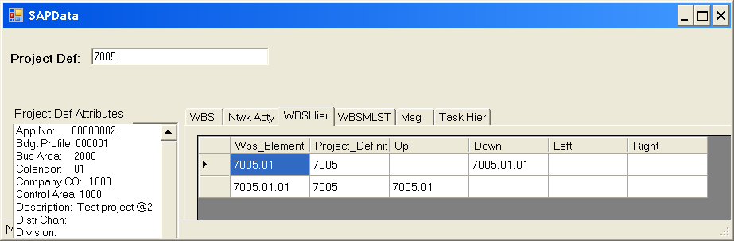
Figure 1. SAP Project WBS Hierarchy data from function BAPI_PROJECT_GETINFO.

The subroutine GetTaskHierarchy accepts two arrays from the preceding data call and populates our control structure arTaskHierarchy. We get the superior WBS hierarchy by processing array arWBSHRCY. Next we get the Network-Activity Hierarchy by processing the provided arNtwkActy array and integrate the two.

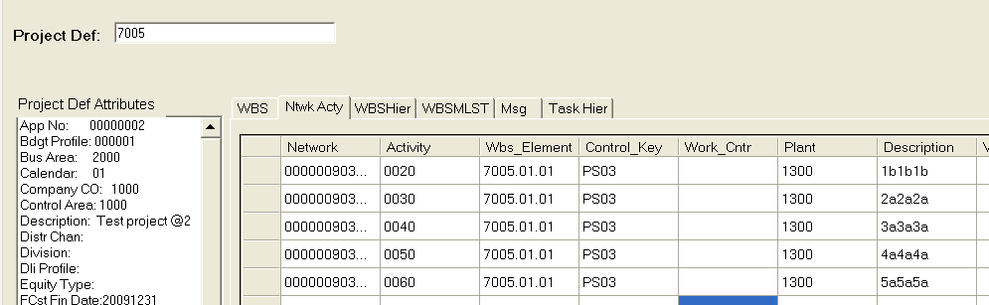
Figure 2. SAP PS Network-Activity data

The Code
public void GetTaskHierarchy(CSAPData.BAPI_WBS_HIERARCHIETable arWBSHRCY,
CSAPData.BAPI_NETWORK_ACTIVITY_EXPTable arNtwkActy)
{
CTaskHier buffTask = new CtaskHier();
int iCount = 0;
// Remove all values in the Task Hierarchy “List” collection
arTaskHierarchy.RemoveAll(Item => Item != null);
//Process WBS hierarchy
for (int I = 0; I < arWBSHRCY.Count; i++)
{
CtaskHier oWBStask = new CtaskHier();

// Start at the root
if (I == 0)
{
oWBStask.Level = 1;
}
else
{ // Check if the “Up” member is different
if (arWBSHRCY[i].Wbs_Element != arWBSHRCY[i].Up)
{
//Get the level of the “Up” ElementID
foreach (CtaskHier t in arTaskHierarchy)
{
if (t.ElementID == arWBSHRCY[i].Up)
{
oWBStask.Level = t.Level + 1;
break;
}
}
}
}
oWBStask.TaskID = I;
oWBStask.ArrayPtr = I;
oWBStask.TaskType = TaskType.WBS;
oWBStask.ElementID = arWBSHRCY[i].Wbs_Element;
oWBStask.SubID = “”;
arTaskHierarchy.Add(oWBStask);
oWBStask = null;
}

//Process Networks and Activities
// Note: Networks with no Activities are not processed
iCount = 1;
for (int I = 0; I < arNtwkActy.Count; i++)
{
// Get the level of the associated WBS
foreach (CtaskHier t in arTaskHierarchy)
{
if (t.ElementID == arNtwkActy[i].Wbs_Element)
{
buffTask = t;
break;
}
}
CtaskHier otask = new CtaskHier();
otask.TaskID = buffTask.TaskID + iCount++; //We insert after the found WBS
otask.ArrayPtr = I;
otask.TaskType = TaskType.Activity;
otask.ElementID = arNtwkActy[i].Network;
otask.SubID = arNtwkActy[i].Activity;
otask.Level = buffTask.Level + 1;
otask.TaskDesc = arNtwkActy[i].Description;
arTaskHierarchy.Insert(otask.TaskID, otask);
otask = null;
}
The end result, loaded in a MS DataGrid is shown below.

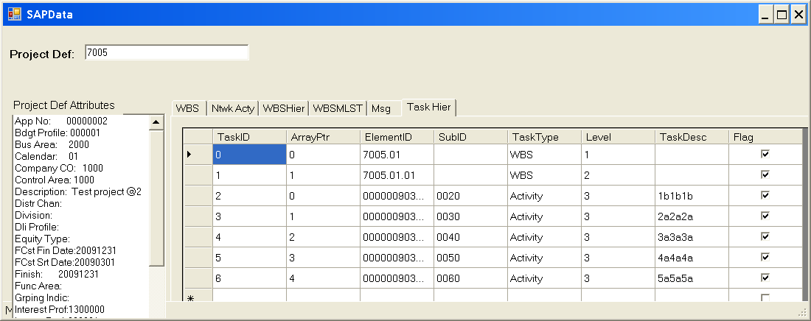
Figure 3. Computed MS Task Hierarchy data

Interfacing with the MS Project application is done by creating a VS C# “Project 2007 Add-In” project. An article describing this can be found at:
http://zo-d.com/blog/archives/programming/making-the-move-from-vba-to-vsto-in-microsoft-project.html

The figure below shows our results. Note that task #6 is flagged as a non-SAP task and hence will not be transferred into SAP.

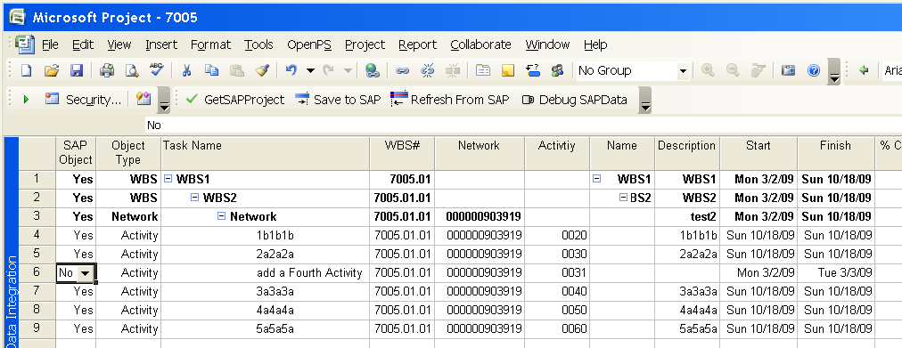
Figure 4. MS Project with SAP data

It’s worth noting that our CTaskHierarchy array will be iterated over and searched extensively in our code. To facilitate, this class is derived from the IEnumerable collection class. Searching in the array is enhanced through the addition of a C# “delegate” to the class. CodeProject has a good article describing this method at:
http://www.codeproject.com/KB/mcpp/csdeleg01.aspx?display=Print.

Sample code: the Delegate Find call
public CTaskHier Find(String sType, String sID, String sSubID)
{
return arTaskHierarchy.Find(delegate(CTaskHier obj)
{ return (obj.TaskType == sType && obj.ElementID == sID && obj.SubID == sSubID); });
}
Provided by: Philip Bremner at http://www.visualsap.net/

